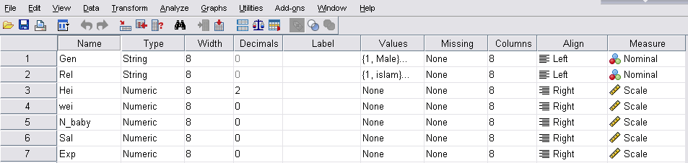

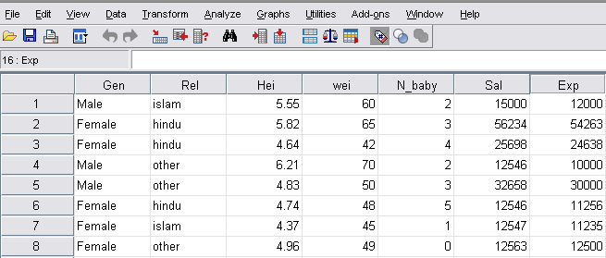

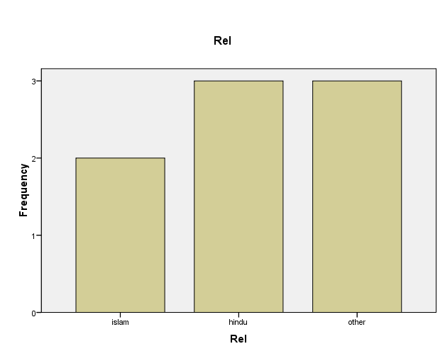

FREQUENCIES VARIABLES=Sal

  /PERCENTILES=57.0

  /STATISTICS=STDDEV VARIANCE

  /BARCHART FREQ

  /ORDER=ANALYSIS.

| **Statistics** | | |
| --- | --- | --- |
| Sal |  |  |
| N | Valid | 8 |
| Missing | 0 |
| Std. Deviation | | 1.560E4 |
| Variance | | 2.434E8 |
| Percentiles | 57 | 1.64E4 |

| **Sal** | | | | | |
| --- | --- | --- | --- | --- | --- |
|  |  | Frequency | Percent | Valid Percent | Cumulative Percent |
| Valid | 12546 | 2 | 25.0 | 25.0 | 25.0 |
| 12547 | 1 | 12.5 | 12.5 | 37.5 |
| 12563 | 1 | 12.5 | 12.5 | 50.0 |
| 15000 | 1 | 12.5 | 12.5 | 62.5 |
| 25698 | 1 | 12.5 | 12.5 | 75.0 |
| 32658 | 1 | 12.5 | 12.5 | 87.5 |
| 56234 | 1 | 12.5 | 12.5 | 100.0 |
| Total | 8 | 100.0 | 100.0 |  |

| **Correlations** | | | |
| --- | --- | --- | --- |
|  |  | Hei | wei |
| Hei | Pearson Correlation | 1 | .978** |
| Sig. (2-tailed) |  | .000 |
| N | 8 | 8 |
| wei | Pearson Correlation | .978** | 1 |
| Sig. (2-tailed) | .000 |  |
| N | 8 | 8 |
| **. Correlation is significant at the 0.01 level (2-tailed). | | | |